**Physician: Dentist:**

___________________________________ _______________________________

Name Name

___________________________________ _______________________________

Phone Number Phone Number

Participant #1:

Please list any allergies to drugs, foods, plants, insects, etc:

Please list any additional information relevant to participating in activities (surgeries; serious injuries, chronic or recurring illness; medical conditions; psychiatric counseling, etc.):

Participant #2:

Please list any allergies to drugs, foods, plants, insects, etc:

Please list any additional information relevant to participating in activities (surgeries; serious injuries, chronic or recurring illness; medical conditions; psychiatric counseling, etc.):

Participant #3:

Please list any allergies to drugs, foods, plants, insects, etc:

Please list any additional information relevant to participating in activities (surgeries; serious injuries, chronic or recurring illness; medical conditions; psychiatric counseling, etc.):

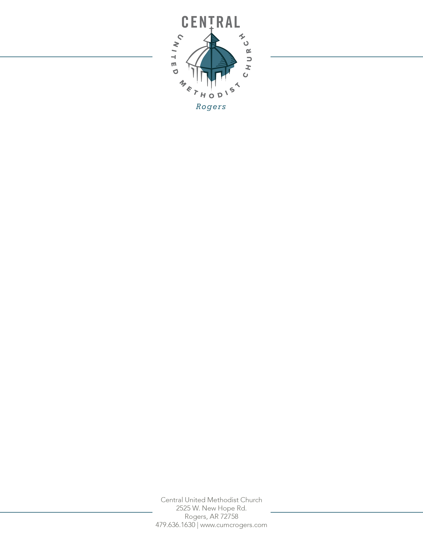

Name(s) Relationship to Participant

Name(s)

**YOUTH MEDICAL RELEASE AND PERMISSION TO TRANSPORT**

**Date: September 1, 2018 – August 31, 2019**

Participant Name: ______________________________________________ Birthdate: _______________

(please use if you have additional children in Gravity Youth Ministry)

Participant Name: ______________________________________________ Birthdate: _______________

Participant Name: ______________________________________________ Birthdate: _______________

**Medical Release**

I hereby request and authorize the CUMC staff and volunteers, hospitals, licensed medical or dental providers, and their agents and employees to have access to the information contained in this form and to provide all medical or dental care, routine tests, treatment, and necessary transportation advisable for the health and safety of my child. This authorization includes the authority to consent to any x-ray examinations, anesthetic, medical procedure or treatment, and hospital care under the supervision, and upon the advice of or be rendered by, a physician or surgeon. If at all possible, an attempt to contact a parent or guardian will be made first.

**Activity and Transportation Release**

I give permission for my child to participate in all supervised activities – including transportation on a church or personal vehicle – except as noted here: _________________________________________________________________________________________

_____________________________________ ________________________________ __________

Signature of Parent or Legal Guardian Printed name of Parent or Legal Guardian Date

**Emergency Contact Information**

**Parent/Guardian**

__________________________________________ Phone Numbers Type (Cell, Home, Work)

|  |  |
| --- | --- |
|  |  |
|  |  |
|  |  |
|  |  |

**Other Emergency Contact**

__________________________________________ Phone Numbers Type (Cell, Home, Work)

|  |  |
| --- | --- |
|  |  |
|  |  |